Dispatch Website Dev HTML/CSS/JS + WordPress (for back end)

|  |  |
| --- | --- |
|  |  |

# **Introduction**

## **Purpose of the document**

This document contains the task to develop a website for Carnivore Trading website.

The document describes the project boundaries, contains all the information that should be taken into account during the project, fixes the project goals and requirements to the project.

On the basis of the information given in the document, works on development of the site concept are carried out. After approval of the document introduction of changes requires additional coordination.

## **Further steps**

The approved document is a single statement of purpose.

# **Website structure**

* Home page
* How it works
* Pricing page
* Get Started page

# **Standard page elements**

### **Page Header**

The page header contains:

* corporate identity element of the site (logo);
* navigation and other elements:



The site logo is a link to the home page of the site, on all pages except the home page. It is not a link on the home page.

By clicking on the navigation links, the user goes to the corresponding page of the site in the current tab.

### **Page Footer**

Page footer contains:

* brand identity element (logo)
* block with links
* social media

Clicking on the links takes the user to the corresponding pages.

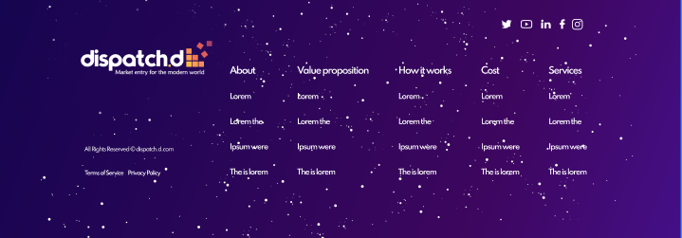

### **Navigation / Breadcrumbs**

"Breadcrumbs" is present on all internal pages of the site. It represents the path on the site from the main page to the current one, where the user is located, in the form of links to the above sections and subsections.

**Page Description**

Home page

### **Page content:**

Page Header

* + Menu:
    - Our approach
    - Services
* How it Works
* Pricing
* Get Started
* The first screen could be slightly animated 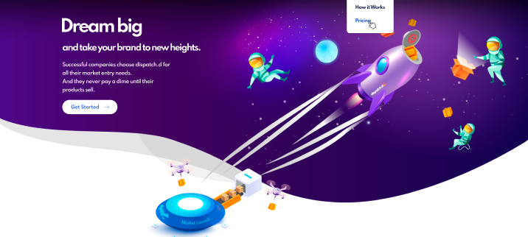
* By clicking on Get Started, customer will be redirected to a form on the Get Started page

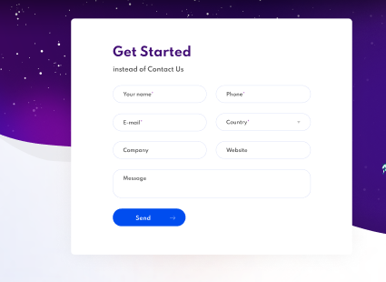

* This section supposed to be a video box open once the customer clicks on play button

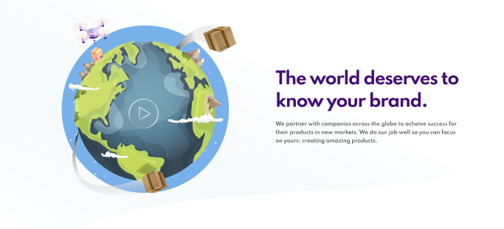

* This section should be slightly animated. By clicking on “More about our approach”, customer will be redirected to How it works page

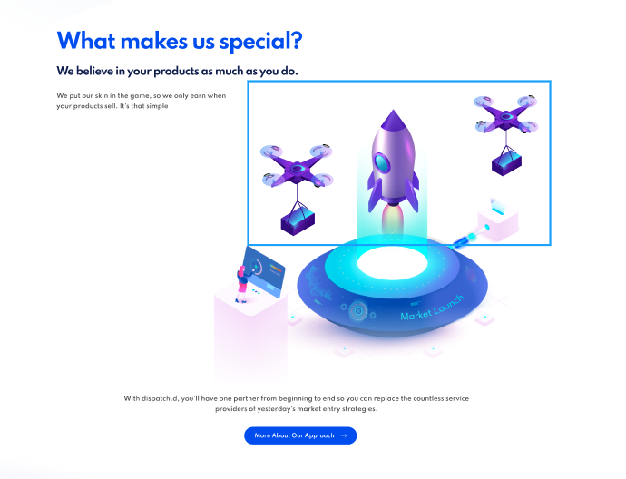

* Our Partner section is static. By clicking on “How it works” button, customer should be redirected to How it works page.

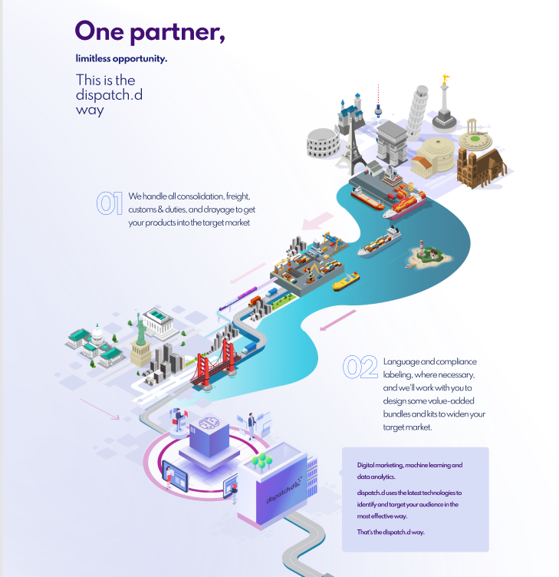

* By clicking on Get Started, customer should be redirected to the Get Started page

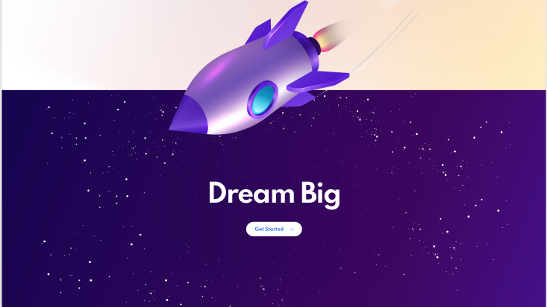

* Testimonial section
* 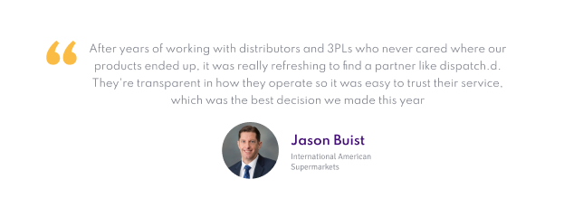
* Section with logo. The something more button there now is just a place holder for the something more logo that we have in development. Once it’s done we want to put it there in the same grey style as the other logos.



How it works page

* The first screen should be slightly animated. By clicking on Learn more, customer should be redirected to the Get Started page
* 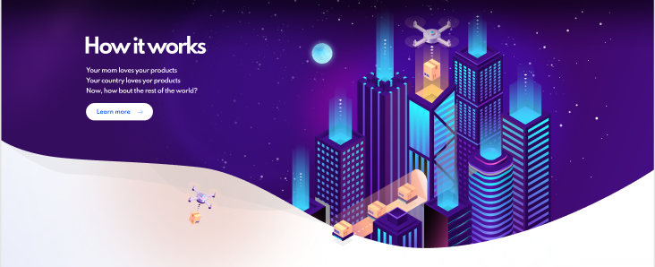
* This section is a text and icons with small titles

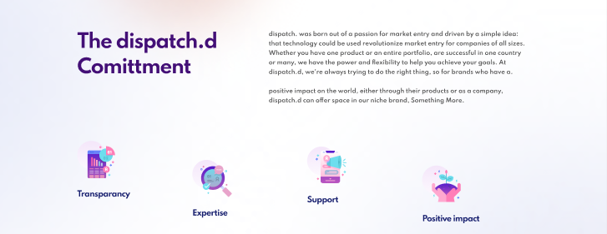

* This section with the text and graphic on the right

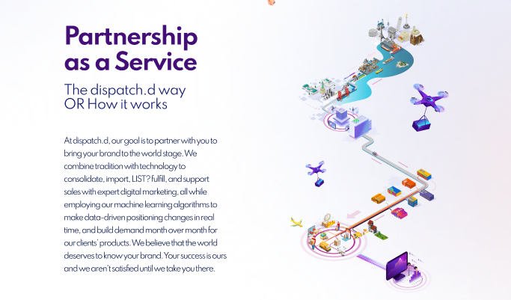

* This section is supposed to work with the help of tabs. By clicking on each tab, customer will see the appropriate information.

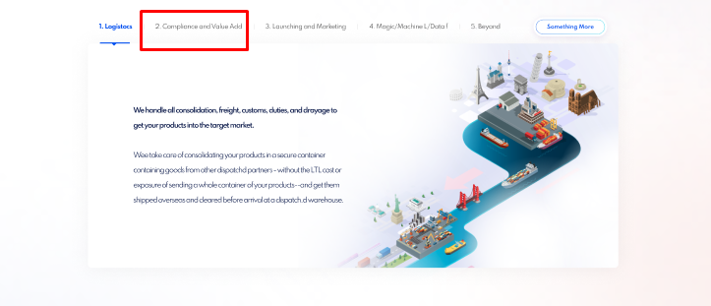

* These sections are supposed to be slightly animated.

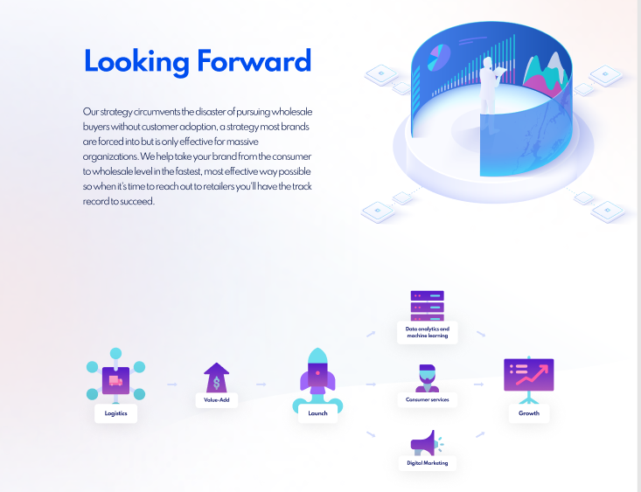

* This section has logos and text on the right. The button isn’t clickable and that it just demonstrates that there are more companies than what are just visible.

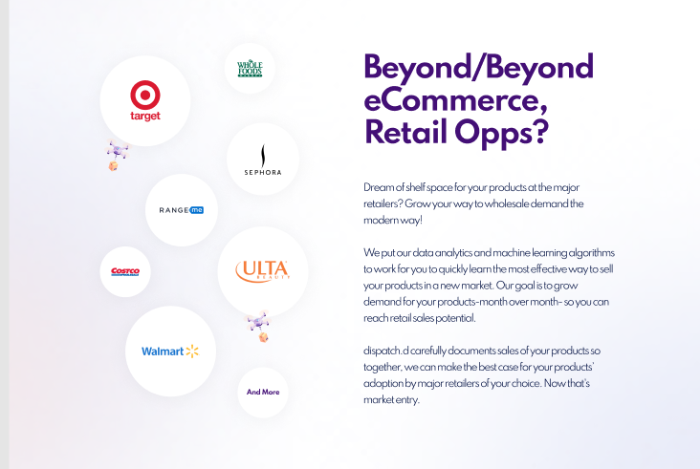

# This is a static section

* 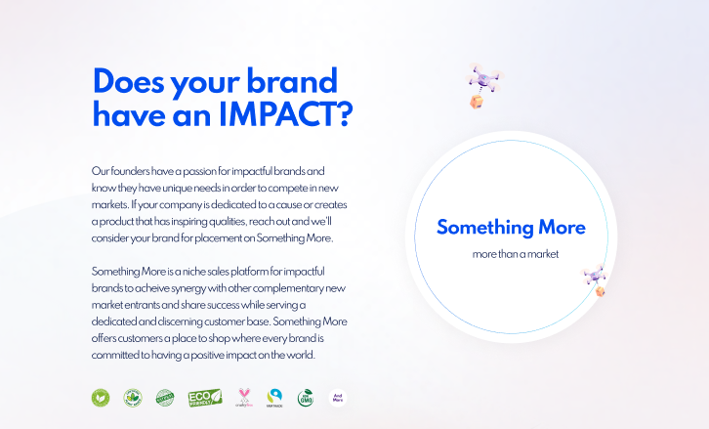

# By clicking on Get started button, custom should be redirected to Get Started page

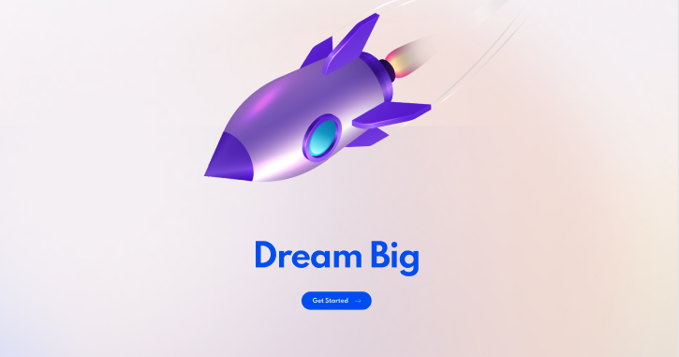

# Pricing page

* The first screen is static

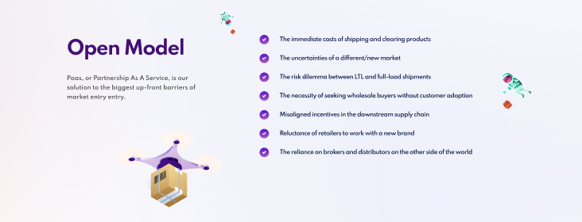

* This screen has hovers on icons.

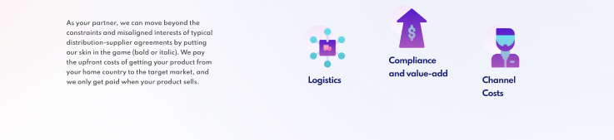

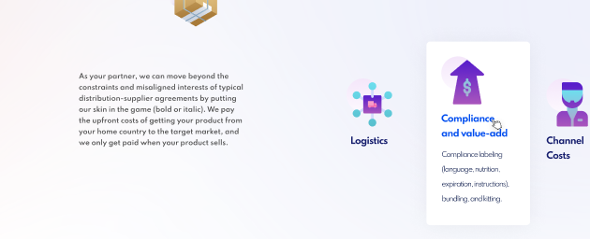

* This screen is a table with hovers

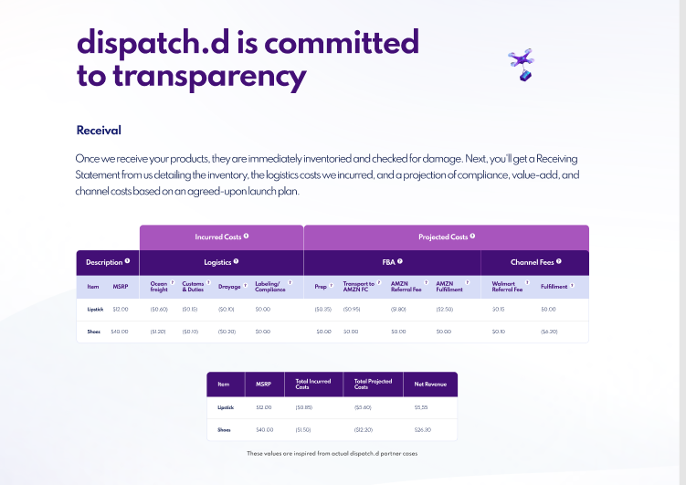

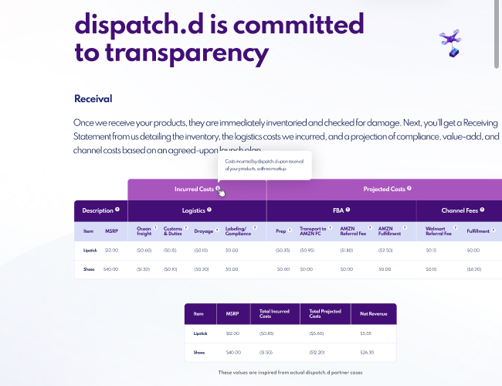

* This is a static section with text and image on the right

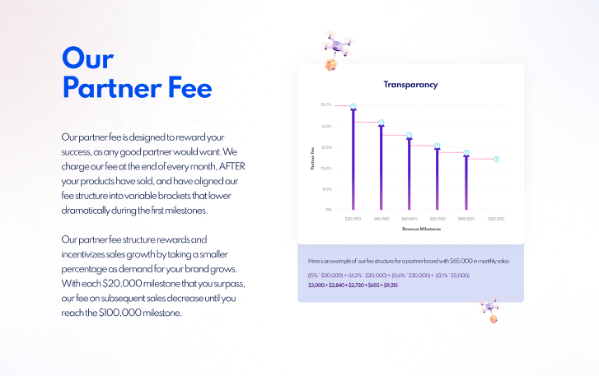

* This is a static section with image and text on the right.

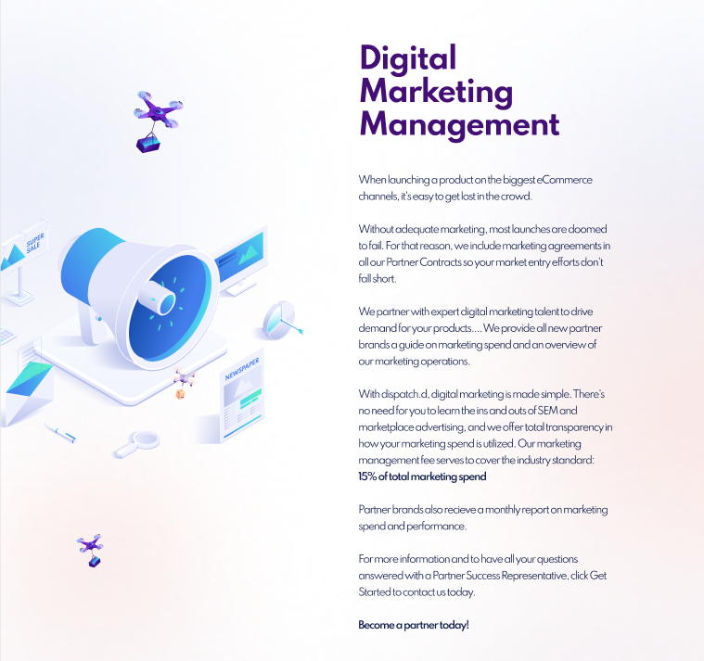

# By clicking on Get started button, custom should be redirected to Get Started page

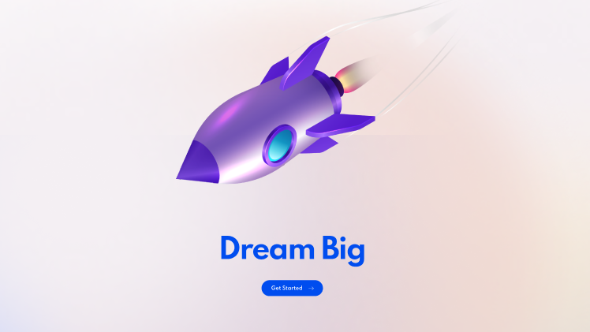

# How it works page

* The first screen is static. By clicking on Learn More, customer will be redirected to Get Started page

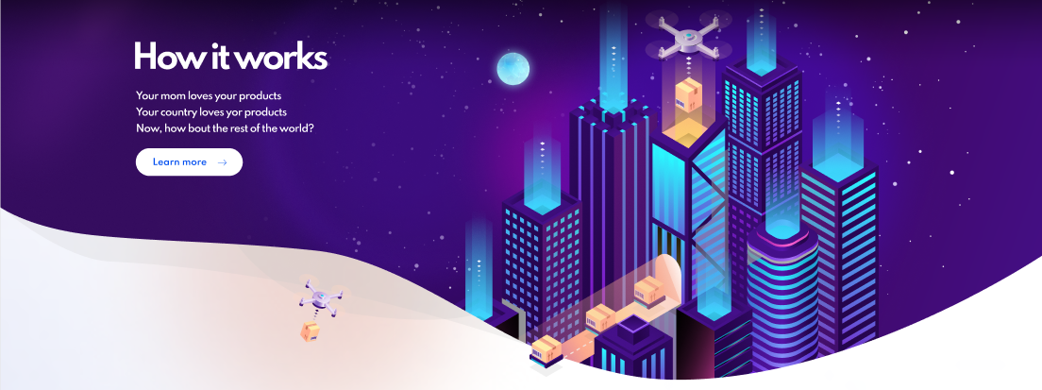

* This section is a static text and icons

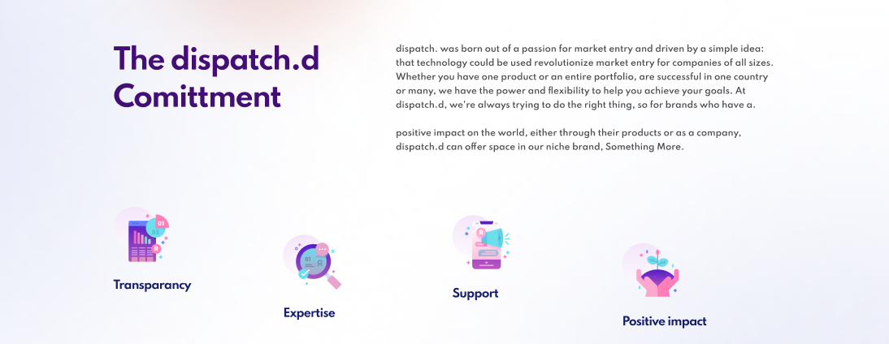

* This section will be static with text and graphic on the right

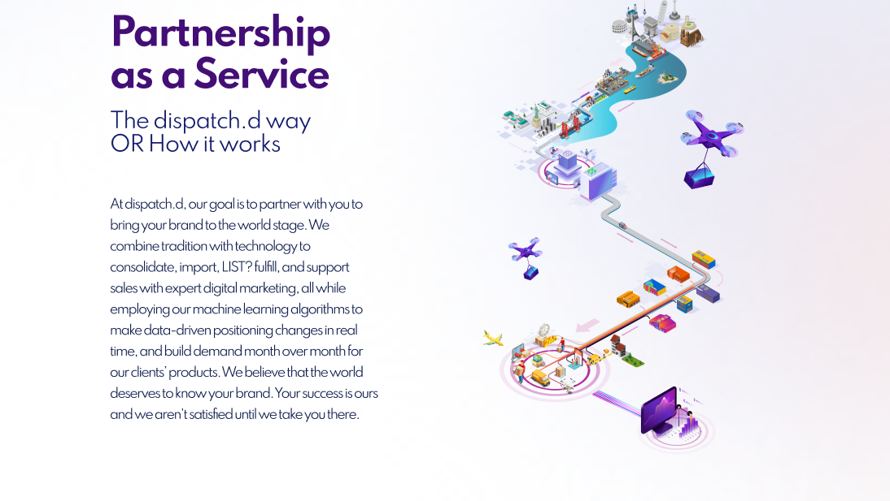

* This section is supposed to work with the help of tabs. By clicking on each tab, the customer will see the appropriate information.

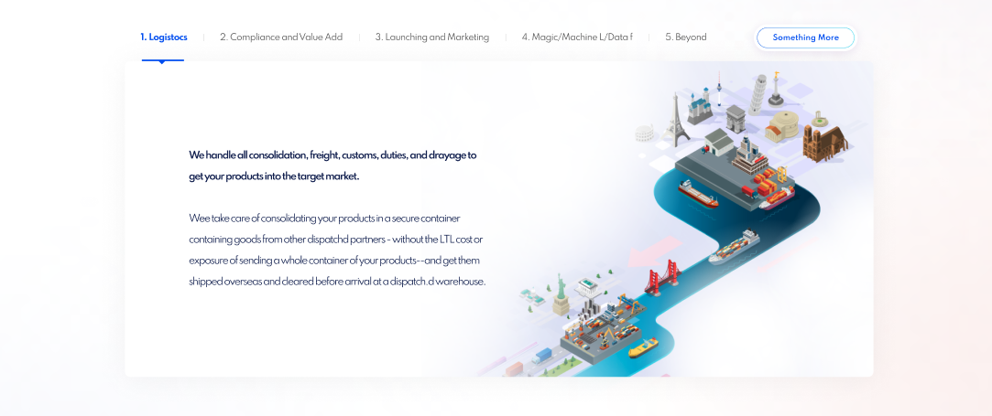

* These sections are supposed to be slightly animated.

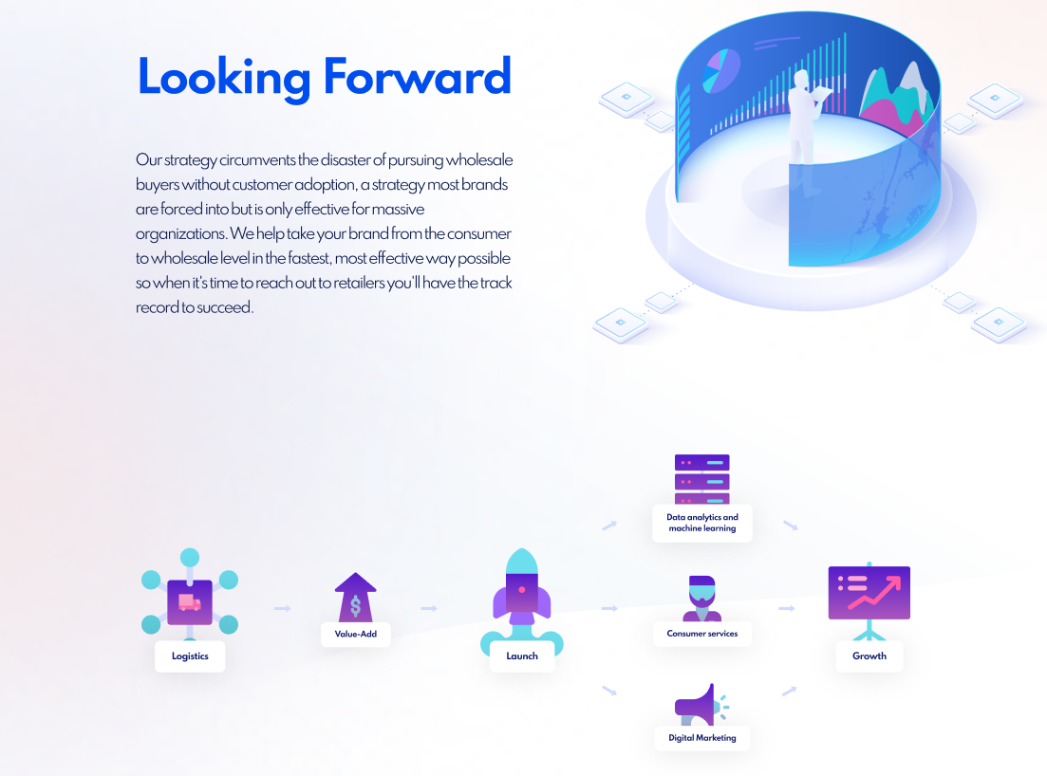

* This section has logos and text on the right. The button isn’t clickable and that it just demonstrates that there are more companies than what are just visible.

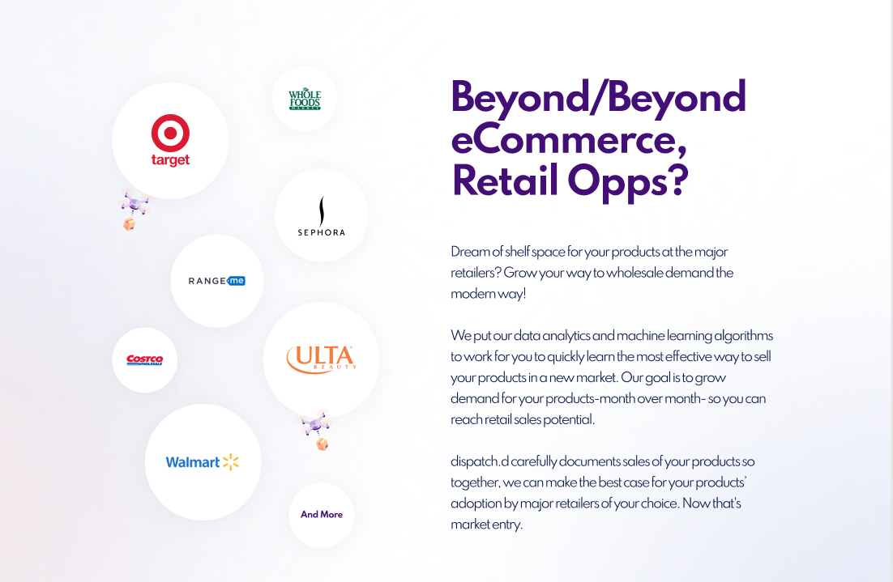

# This is a static section

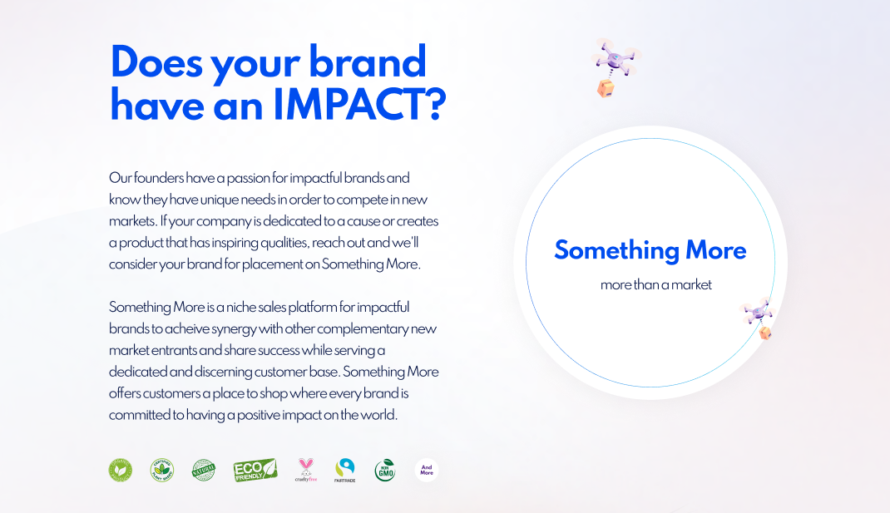

# By clicking on Get started button, custom should be redirected to Get Started page

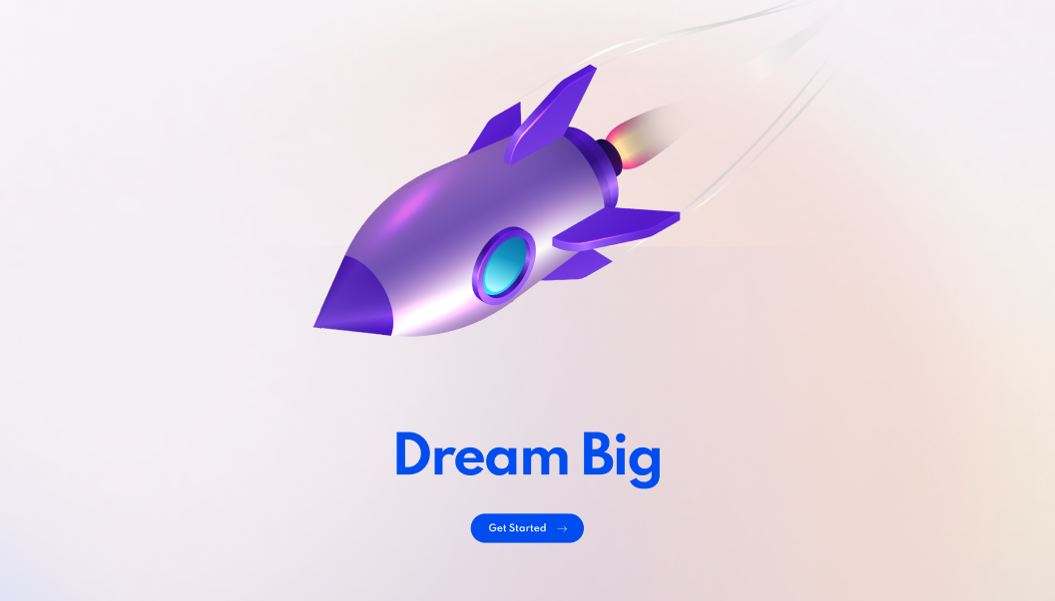

# Get Started page

* The first section has a form.

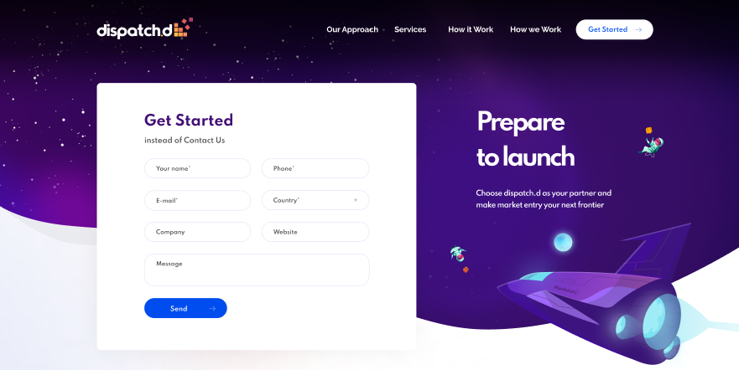

* This section supposed to be a video box open once the customer clicks on play button

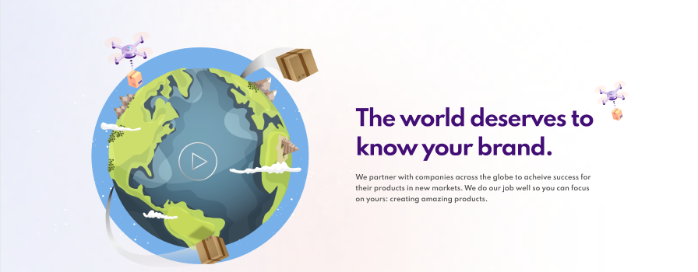

* This section is supposed to work with the help of tabs. By clicking on each tab, the customer will see the appropriate information.

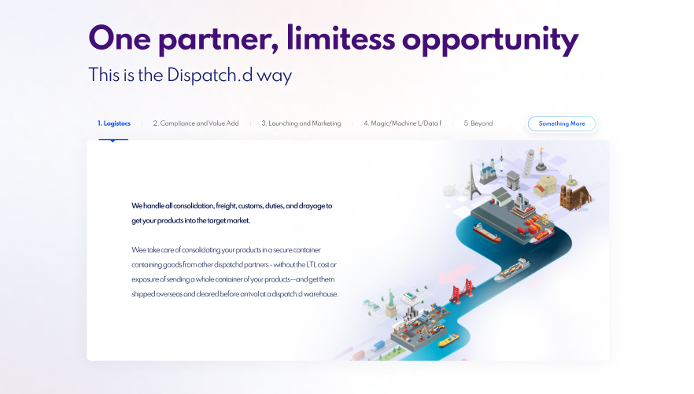

* This is a static section with image and text on the right.

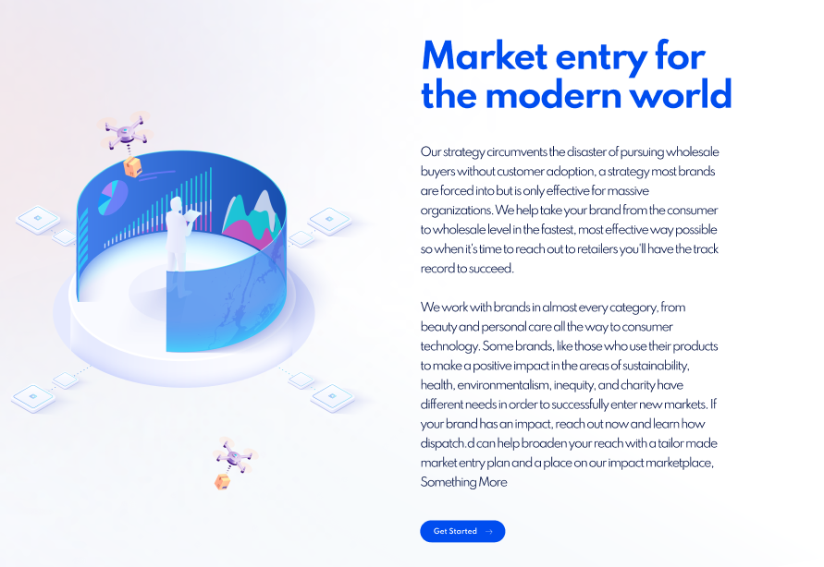

* Testimonial section

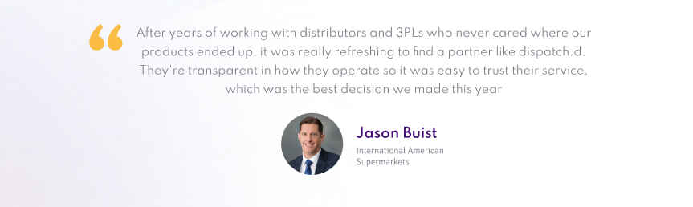

* Section with logo. The something more button there now is just a place holder for the something more logo that we have in development. Once it’s done we want to put it there in the same grey style as the other logos

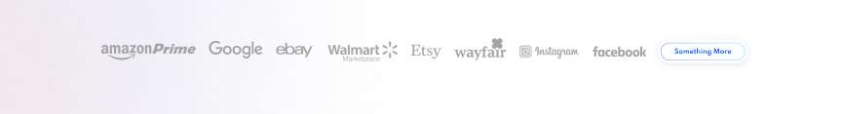

# **Functional requirements**

## **Language versions**

Only the English version of the site is implemented.

## **Language requirements for the admin interface**

The language of admin interface of the site management system is English.

**Requirements for admin interface functionality**

The structural and architectural interface is developed at the programmer's discretion.

The following has been done:

* structured interface;
* clear names of elements / infoblocks;
* fields group in the elements by logical value.

# **Nonfunctional requirements**

## **Content**

Content is provided by the customer

**Front end and back end requirements**

HTML/CSS/JS - front-end.

WordPress - back end.

## **Layout requirements**

1. The layout of the site pages must be correctly (without visual and technical errors) displayed and cross-browser in the following browsers:
   * Mozilla Firefox версии 76+;
   * Opera 67+;
   * Google Chrome версии 81+;
   * Apple Safari версии 8+

on Windows and Mac OS, with graphics enabled, when the user's screen resolution is from 1280 points, width, and above. The layout of the site pages should be correctly (without visual and technical errors) displayed on mobile devices in iOS 10+, Android 10+ operating systems.

1. The layout of the site must comply with the design approved by the parties.

**Search Engine Requirements**

#### **General**

* The site must meet the requirements of Google's search engine for ease of viewing on mobile devices. Requirements are shown on the page <https://developers.google.com/speed/docs/insights/mobile>.

#### **Text**

* Text must be placed as text (not pictures). It is desirable that access to the text was not hampered by various design solutions - it was available immediately, not opened by click / hint, etc. Text should not be hidden by java scripts.
* The text on the site should be easy to read, formatted and free of spelling errors.
* All pages of the site must contain unique text.
* There should be 1 header with tag H1 in the text of the page, which should include key words/phrases, headings with tag H2 in the text can be 2, and they should also include key words/phrases. You must not place the entire page text in the title tag.
* The headings should be at least partially navigation compatible.

#### **Images**

* The Alt-attribute should be prescribed in all pictures. The Alt should include the words promoted on a particular page. You should not insert more than 7 words into the alt attribute. As for images, they must be unique.
* Common image extensions must be used (JPEG, GIF, PNG, and BMP).
* The image can be opened as a separate page without text, but only if the image is present on a standard page, or opened separately in an enlarged form.

#### **Meta tags**

* It should be possible to edit meta tags and add text.
* Tag <title> must correspond to the content of the page and include the main search queries, must contain no more than 64 words.
* Tag <title> must correspond to the content of the page and include the main search queries, must contain no more than 64 words.
* Meta tags must contain a branded keyword.

**Animation**

Scroll by scroll slight animation, similar to this video

https://drive.google.com/file/d/1043QhwxEB5A8hFh9o_mYbbhQbFJBpZIY/view?usp=sharing

Link to Figma:

https://www.figma.com/file/OSezZJgfnH1xgTSDQK3fCL/36.-Dispatch.D-DEV?node-id=241%3A1853

**Access Credentials**